Q. What is Scalability in System Design?
https://www.youtube.com/watch?v=TXJP0gzCXFQ

Scalability:
Ability of system to handle more users/load.
The system should not slow down when traffic increases.

Two types:
- Vertical scaling (increase server power)
- Horizontal scaling (add more servers)
Used to avoid system crash
Important for large applications

Q. Monolith vs Microservices simple explanation?
https://www.youtube.com/watch?v=rv4LlmLmVWk

Q. What is Load Balancer simple explanation?
https://www.youtube.com/watch?v=sCR3SAVdyCc

Load Balancer is used to distribute the user’s requests (Load) among the multiple servers to handle it so that a single server should not be overloaded by upcoming users requests/traffic. So, it enhances the performance of our application.
It distributes the traffic in round robin fashion or randomly on the basis of some algorithm.

Types: Round Robin, Least Connections?
https://www.youtube.com/watch?v=0suOpFXXAj0

Difference between L4 vs L7?
https://www.youtube.com/watch?v=S4GsSTb4hxs&t=209s

L4: Transport layer Load balancer = Network Load balancer
It handles trafiic based on IP addresses and TCP/IP ports. It is used in non HTTP/S traffic for internal network load balancing.

L7: Application layer Load balancer = Application Load balancer
It handles trafiic based on the content of the message. It is used in HTTP/S traffic.

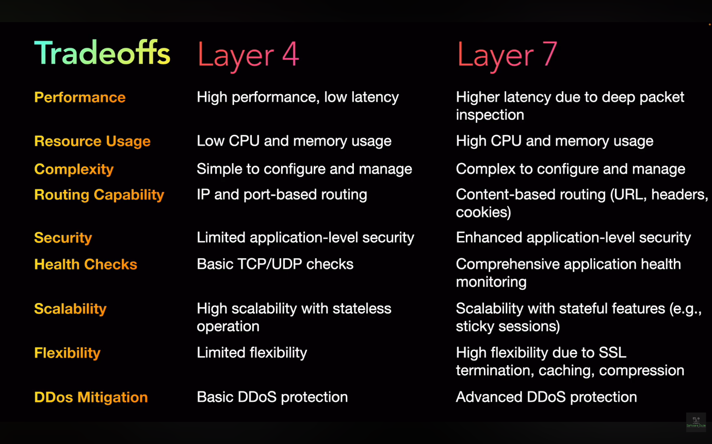

Q. What is Caching in System Design simple explanation?
https://www.youtube.com/watch?v=xBTGln828Ps

Caching (System Design)
- Caching is a technique to store frequently used data temporarily
- It helps reduce latency and improves performance

How it works:
- First request → fetch from DB/server (slow)
- Response stored in cache
- Next requests → served from cache (fast)
- When data updates → cache is invalidated/updated

What can be cached:
- API responses
- Database query results
- Images, HTML, CSS

Types of Cache:
1. In-Memory / Local Cache
- Stored inside application/server memory
- Very fast
- Example: Memcached

2. Distributed Cache
- Shared across multiple servers
- Used in scalable systems
- Example: Redis

When to use:
- Read-heavy systems
- Frequently accessed data
- Mostly static or rarely changing data

CDN (Content Delivery Network):
- Stores static content closer to users geographically
- Reduces latency

Example:
- User in India gets data from India server instead of USA

Caching is a technique to store frequently accessed data temporarily so that future requests can be served faster instead of hitting the database again.

Q. What is Database Indexing simple explanation?
https://www.youtube.com/watch?v=xXtig5uLQS4

“Indexing is a technique used to improve query performance by creating a data structure on specific columns, allowing the database to quickly locate rows instead of scanning the entire table.”

- Indexing is a technique to improve the speed of data retrieval
- It helps avoid full table scan

How it works:
- Without index → database scans each row (slow)
- With index → database uses a data structure (like B-Tree) to find data quickly

Key Points:
- Created on column(s) used in WHERE, JOIN, ORDER BY
- Improves read/query performance
- Uses extra storage

Trade-offs:
- Slows down INSERT, UPDATE, DELETE (because index also needs update)

When to use:
- Large tables
- Read-heavy systems
- Frequently searched columns

When NOT to use:
- Small tables
- Write-heavy systems

Example:
- Searching netWorth = 4000
- Without index → linear scan
- With index → fast lookup using index structure

Types of indexes (just awareness):
- Primary Index
- Secondary Index
- Composite Index

Concept: Database Sharding
What is sharding?
Why not a single DB for large systems?
Sharding strategies:
- Range-based
- Hash-based
Basic pros/cons (hotspots, complexity)

https://www.youtube.com/watch?v=YCb-tDQWrXk
https://www.youtube.com/watch?v=arUpleGFdt4
https://www.youtube.com/watch?v=avepna2q9w0
https://www.youtube.com/watch?v=62adurZ_Muw

Suppose, we have an Employees table having the columns and rows.
EmpId | Name | City | State | Country | Designation | Salary | Date of Joining
1 | Ali | Meerut | UP | India | SE | 20 LPA | 15-01-2000
2 | Bablu | Noida | UP | India | SSE | 25 LPA | 19-09-2005
3 | Celina | Hyderabad | Telangana | India | TL | 45 LPA | 23-07-2009

Vertical Partitioning:
Splitting a table by columns, where different columns are stored in separate tables (or sometimes separate services), usually linked by a common key (e.g., EmpId). For example:
Table1: EmpId, Name
Table2: EmpId, Salary

Horizontal Partitioning (Sharding):
“Database sharding is the horizontal partitioning of data across multiple databases or nodes, where each shard stores a subset of rows with the same schema to improve scalability and performance.”
So, Sharding = Horizontal Partitioning ONLY.

Logical Partitioning: Data is divided conceptually based on a rule such as ID ranges, hashing, or geography. For example, users with IDs 1–1M, 1M–2M, etc.
Physical Partitioning (Sharding): These logical partitions are mapped to actual physical databases or servers (called shards).
Example:
- Logical Partitions:
  - 1–1M → Partition-1
  - 1M–2M → Partition-2
  - 2M–3M → Partition-3
  - 3M–4M → Partition-4
- Physical Mapping:
  - DB-1 → Partition-1, Partition-2
  - DB-2 → Partition-3, Partition-4

Algorithmic Sharding (Client-Side Sharding):
In this approach, the application contains the logic to determine which shard to use for a given request. This is typically done using a deterministic function such as hashing or range-based rules.
Since the routing logic is embedded in the application, no external lookup service is required. However, changing the number of shards is difficult and often requires data rebalancing.

Advantages of Sharding:
[1] Horizontal Scalability: You can add more machines (shards) to handle increasing data and traffic.
[2] Improved Performance & Low Latency: Queries run on smaller datasets within a shard → faster response time.
[3] High Throughput: Multiple shards handle requests in parallel.
[4] Fault Isolation: Failure of one shard does not bring down the entire system.
[5] Better Resource Utilization: Load is distributed across multiple servers instead of overloading one.

Disadvantages of Sharding: “Sharding trades simplicity for scalability—while it improves performance, it significantly increases system complexity, especially around data consistency, joins, and rebalancing.”
1. Increased System Complexity
- Application logic becomes complex (routing, retries, failures)
- Operational overhead (monitoring, backups, scaling)

2. Hotspots / Uneven Data Distribution
- Some shards receive more data or traffic than others
- Leads to performance bottlenecks
- Caused by poor shard key or skewed access patterns

3. Difficult Rebalancing (Resharding)
- Adding/removing shards requires:
  - data migration
  - downtime or complex orchestration

4. Cross-Shard Queries are Expensive
- Joins across shards are difficult or inefficient
- Often require:
  - multiple queries
  - data aggregation at application layer

5. Distributed Transactions are Hard
- ACID transactions across shards are complex
- Need 2PC or eventual consistency

6. Operational Overhead
- Backup, replication, monitoring per shard
- More infrastructure to manage

7. Hard to Rollback
- Once implemented, reverting to a single DB is difficult
Key-Based (Hash-Based) Sharding:
In this approach, a shard key (such as EmpId) is passed to a hash function, which determines the shard where the data should be stored. The hash function is deterministic, meaning the same key will always map to the same shard.
The goal of hashing is to distribute data evenly across shards to avoid hotspots. However, changing the number of shards requires rehashing and data redistribution, which can be costly.

Advantage of Key based Sharding:
- Provides uniform data distribution across shards
- Helps avoid hotspots and load imbalance

Disadvantage of Key based Sharding:
- Resharding is expensive: When the number of shards changes, the hashing function changes, causing many keys to map to different shards
- Requires data redistribution (migration) across shards
- Can lead to downtime or complex data movement strategies
So, “the biggest drawback of hash-based sharding is that adding or removing shards requires rehashing and moving large amounts of data.”
Solution:
“To minimize data movement during scaling, systems use consistent hashing.”
Used in:
- Apache Cassandra
- Amazon DynamoDB

How to choose sharding key?
A shard key should be selected based on the following criteria:
- High Cardinality: The key should have many unique values to ensure proper distribution (e.g., UserId).
- Uniform Distribution: Data should be evenly spread across shards to avoid hotspots.
- Query Pattern Alignment: Most queries should include the shard key to avoid cross-shard operations.
- Low Update Frequency: The shard key should not change frequently, as updates require data migration.
Composite keys can be used when needed, but they should still satisfy the above properties.

Range-Based Sharding:
In this approach, data is partitioned based on value ranges of a shard key. Each shard is responsible for a specific range of values.
Examples:
- Employees divided by Date of Joining (Jan–Mar, Apr–Jun, etc.)
- Products divided by price ranges
Advantages of Range-Based Sharding
- Simple and intuitive to implement
- Efficient for range queries (>, <, BETWEEN)
- Easier to manage and modify compared to hash-based sharding

Disadvantages of Range-Based Sharding
- Hotspots due to uneven data distribution means the data storage will be increased in one shard.
- Sequential inserts can overload a single shard (e.g., timestamp-based data)
- Requires manual rebalancing when data distribution becomes skewed

Use Cases
- Applications with frequent range queries
  - e.g., date ranges, price filters
- Time-series or reporting systems (with proper load balancing)

Directory-Based Sharding (Dynamic Sharding):
In this approach, a separate lookup service or metadata store maintains the mapping between shard keys and physical shards. The application queries this service to determine which shard to use for read/write operations.

Advantages
- Supports dynamic scaling (easy to add/remove shards)
- No changes required in application logic
- Flexible shard mapping and easier rebalancing

Disadvantages
- Extra network hop → increased latency
- Dependency on lookup service (potential single point of failure)
- Additional operational complexity
- Possible consistency issues if mapping becomes outdated

